TECHNICAL PROJECT REPORT

# SOUND DETECTING DEVICE

# Team Members / Inventors:

|  |  |  |  |  |  |
| --- | --- | --- | --- | --- | --- |
| **S. No.** | **Name** | **Department** | **Designation** | **Mobile** | **E-Mail** |
| 1. | DEEPANSHU | CSE-IOT | Student | 8376052927 | mahtodeepanshu27@gmail.com |
| 2. | ADITYA | CSE-IOT | Student | 8527311187 | adi.bansal00.ab@gmail.com |
| 3. | RITESH | CSE-IOT | Student | 7992451778 | choubeyritesh123@gmail.com |
| 4. | KARTIK | CSE-IOT | Student | 7056890089 | kartiks19102000@gmail.com |
| 5. | Khushal Thakur | ECE | Mentor | 9646030764 | khushal.thakur@cumail.in |
| 6. | Anshul Sharma | ECE | Mentor | 9478697475 | anshulsharma.ece@cumail.in |
| 7. | Kiran Jot Singh | ECE | Mentor | 9463909689 | kiranjotsingh.ece@cumal.in |
| 8. | Divneet Singh Kapoor | ECE | Mentor | 9878422653 | divneet.ece@cumail.in |

Section – 1 (IPR Related)

# Problem Solving Project:

Sound detecting device used to detect presence of sound in any place.

# Solving Solution:

* In case there is sound in any room, this circuit will sense that and sends a text message to the user.
* It can be used as a burglar alarm, safety measures, or in libraries.

# Additional Modifications:

* We can add 3 coloured LEDs, RED for high sound frequency, YELLOW for moderate sound frequency and GREEN for low sound frequency.

# Existing State-of-the-Art and Drawbacks in Existing State-of-the-Art:

|  |  |  |
| --- | --- | --- |
| **S. No.** | **Existing state of art** | **Drawbacks in existing state of art** |
| 1 | Senses judging device (PUB no. EP2116999B1). | The device buzzes and alarm when detects sound. The owner may not be notified about it. |
| 2 |  |  |

# Additional modifications that you can propose to improve upon drawbacks:

* Feature 1: Remove the buzzer and add a text message service.

# Advantages:

* Adv 1: the user gets notified without informing the intruders.

# Block Diagram:

GSM MODULE

ARDUINO UNO

SOUND SENSOR

(INPUT)

Section – 2 (Real Project)

# Materials:

* 1 x SOUND SENSOR (Detects sound using microphone. Operating Voltage- 3.3V-5V)
* 1 x ARDUINO UNO (Microcontroller- ATMEGA328, Operating Voltage- 5V)
* 1 x GSM MODULE (GPRS, Bluetooth, Dual-Band 900/1800 MHz)
* 6 x JUMPER WIRES
* 1 x ADAPTER (12V-2A)
* 1 x SIM

# Circuit Diagram:

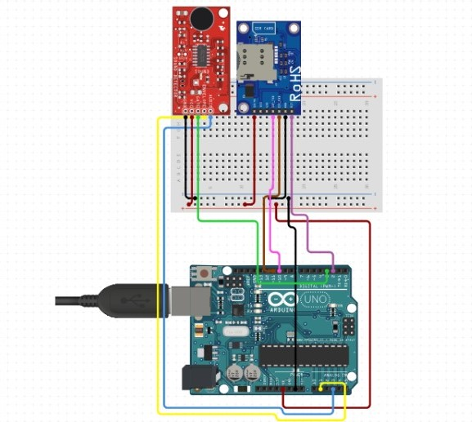

# Steps of Circuit Completion:

1. 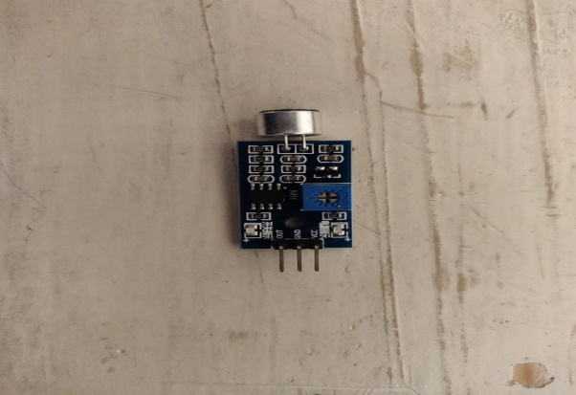
2. 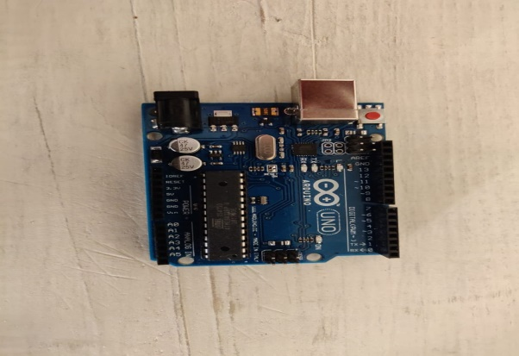
3. 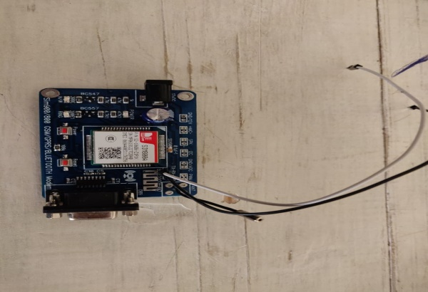
4. 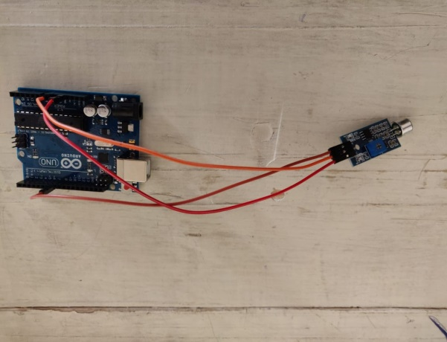
5. 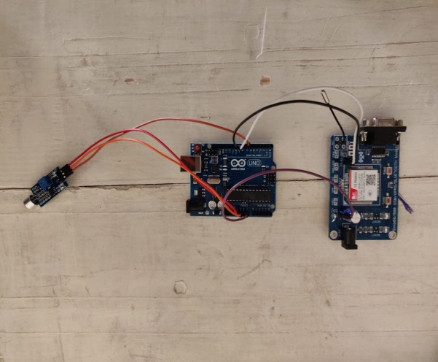
6. 